

A Project

Report On

**Hotel Management System**

**By**

# Koduri Malakondareddy

# B.Tech(EEE)

**Batch:2020-5355**

**Center:Bangalore-TC/Palya**

Under the Guidance of,

**V. Jayanth**

**TechnicalTrainer**

**EduBridge**

(Schoolofcoding)

**Introduction:**

In conditions of increasing global competition, demands and needs of consumers, quality and quality management have become fundamental strategic factors of achieving profitability and competitiveness on the relentless tourism market. Any serious "top" hotel management, with a defined mission, vision and goals, must define a "special policy" of improving the quality of hotel services through "structural programs of quality improvement," which have become an important factor in the hotel business. With the design, introduction and control of a "special program" of quality improvement of hotel services, hotel management can have a positive impact on increasing satisfaction of customers and human resources, increasing competitiveness and market power of the hotel, the rationalization of operating costs and enhance the reputation and value of the hotel on the demanding tourist market**.**

**OurProjectIncludeModules:**

* Admin Module
* Login Module
* Registration module

I have developed this Application in **Java, JSP, Servlets, and MySQL.** It’s a web-based projects so I have used **HTML, CSS**.

**Admin:**

Admin can add packages he/she want. While adding the package he should give the package name, place, number of days, cost. If he/she add same package name with same place the package will not be added if admin add same package name but different place then it will be added.

Admin should add hotels first so that he/she can add rooms later with respective to the hotel name. In room admin should add type and size of the room and finally cost of the room.

Admin can also add the food by selecting which type of food he want to be added.

Finally he/ she can also add the transport like which type of vehicle user may need.

Admin can update/delete the package, room, food and transport which was added by him/her.

He/she can add the percentage of discount for any package which was selected by user as his/her 1st package.

Admin can also update the discount program like changing the discount percentage or deleting the discount.

He/she can view all the payment details finally made by the users.

**Login:**

User should register to the site with all the required details. And then he/she can login to the site. User can also reset their password if they registered already.

User can search for the packages which were added by the admin. He/ she can view the packages with place in a table by selecting any package name displayed in the dropdown box.

User can book their food, transport and room only if they book any package in the site. If they don’t book any package then they cannot book any of the things listed above.

User can view different types of room and size of room by selecting the hotel name. Coming to food they can book any kind of food by selecting type of food they want. Similarly, they can book there transport by selecting the mean of transport they want to travel.

User can view there packages, food, room and transport they have booked and they can modify / cancel them according.

Finally, they can view their conformation page where they can see the total cost of the package that is sum of package cost, room cost, food cost and transport cost so that they can pay the total money.

In this payment they will get 10% discount for their first package and 30% discount for their 3rd package. In additional to the 10% for the 1st package they can get any additional discounts if available for the selected package which are added by admin.

**SoftwareRequirements:**

**Front end:** Java/J2EE technologies (Servlet, JSP), HTML, CSS

**Backend**:MySQLworkbench 8.0.25

**Middleware/Server:** Apache Tomcat v7.0. IDE: Eclipse IDE for Java EEDevelopers

**Browser:** Best result on Google Chrome

**Operating System:**Window10.

# DataDictionary

CREATE DATABASE HOR;

USE HOR;

CREATE TABLE `admin` (

`admin_id` int(11) NOT NULL auto_increment,

`name` varchar(30) NOT NULL,

`username` varchar(24) NOT NULL,

`password` varchar(24) NOT NULL,

PRIMARY KEY (`admin_id`)

) ENGINE=InnoDB DEFAULT CHARSET=latin1;

INSERT INTO `admin` VALUES (2,'Kishor Kadam','kadamk329','java@1991'),(4,'Sagar Kharmale','sagar','sagar@123'),(5,'Govind Raut','govind','raut@12345'),(7,'Santosh Karvekar','santosh','santosh@123');

CREATE TABLE `guest` (

`guest_id` int(11) NOT NULL auto_increment,

`firstname` varchar(50) NOT NULL,

`middlename` varchar(30) NOT NULL,

`lastname` varchar(40) NOT NULL,

`address` varchar(50) NOT NULL,

`contactno` varchar(13) NOT NULL,

PRIMARY KEY (`guest_id`)

) ENGINE=InnoDB DEFAULT CHARSET=latin1;

INSERT INTO `guest` VALUES (1,'Kishor','Balasaheb','Kadam','Wakad,Pune','9404308673'),(2,'Sagar','Prakash','Kharmale','Malwadi,Pune','7276763516'),(3,'Raju','Balasaheb','Kadam','A/P: Bhalawani Tal: Parner Dist: Ahmednagar','9889898965'),(4,'Santosh','Ramchandra','Karvekar','Chipurde,Sangali','8855743651'),(5,'Shivaji','Abc','Manchare','MIDC,Ahmednagar','9638527410'),(6,'Dharmesh','Xyz','Mourya','Andheri,Mumbai','8474563214');

CREATE TABLE `room` (

`room_id` int(11) NOT NULL auto_increment,

`room_type` varchar(50) NOT NULL,

`price` varchar(11) NOT NULL,

`photo` varchar(100) NOT NULL,

`photo_path` varchar(500) default NULL,

PRIMARY KEY (`room_id`)

) ENGINE=InnoDB DEFAULT CHARSET=latin1;

INSERT INTO `room` VALUES (1,'Standard','700','1.jpg','F:/Java-Programming-All-Work/All Webbased Programs/HotelManagementSystemDashboard/WebContent/uploads/1.jpg'),(2,'Superior','1700','2.jpg','F:/Java-Programming-All-Work/All Webbased Programs/HotelManagementSystemDashboard/WebContent/uploads/2.jpg'),(3,'Super Deluxe','3000','6.jpg','F:/Java-Programming-All-Work/All Webbased Programs/HotelManagementSystemDashboard/WebContent/uploads/6.jpg'),(6,'Jr. Suite','500','11.jpg','F:/Java-Programming-All-Work/All Webbased Programs/HotelManagementSystemDashboard/WebContent/uploads/11.jpg'),(7,'Executive Suite','4500','5.jpg','F:/Java-Programming-All-Work/All Webbased Programs/HotelManagementSystemDashboard/WebContent/uploads/5.jpg');

CREATE TABLE `travel` (

`id` int(11) NOT NULL auto_increment,

`apply_date` date default NULL,

`day` int(11) default NULL,

`departure_date` date default NULL,

`status` varchar(45) default NULL,

`guest_id` int(11) default NULL,

`room_id` int(11) default NULL,

`room_no` int(11) default NULL,

`extra_bed` int(11) default NULL,

`bill` double default NULL,

PRIMARY KEY (`id`)

) ENGINE=InnoDB DEFAULT CHARSET=latin1;

INSERT INTO `travel` VALUES (1,'2019-07-20',4,'2019-07-24','CheckOut',1,7,101,3,20400),(2,'2019-07-20',2,'2019-07-22','CheckIn',2,2,401,0,3400),(3,'2019-07-20',7,'2019-07-27','CheckOut',3,3,201,5,25000),(4,'2019-07-20',9,'2019-07-29','CheckOut',4,1,301,1,7100),(5,'2019-07-20',1,'2019-07-21','CheckOut',5,6,501,7,6100),(6,'2019-07-20',8,'2019-07-28','Pending',6,3,0,0,0);

# Screenshots:-

**Home page:**

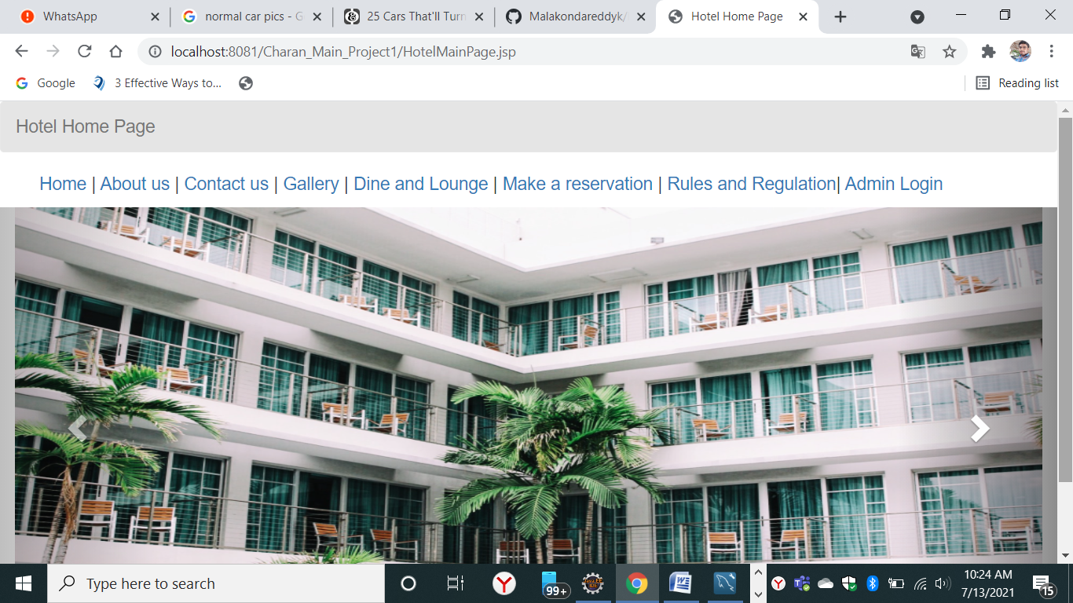

**Login With Admin Details:**

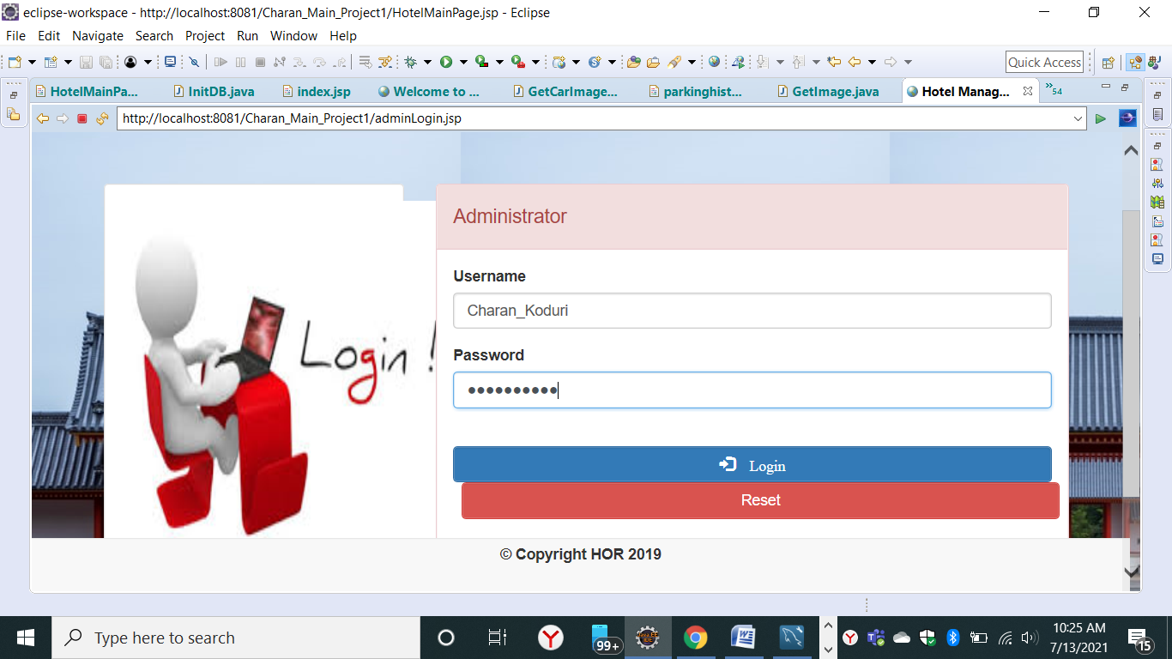

**Admin Welcome Page:**

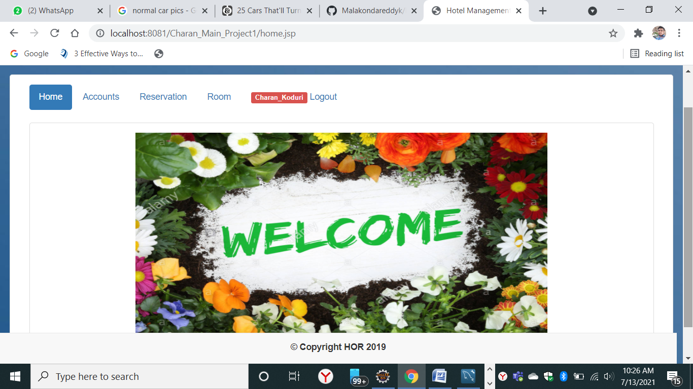

**Contactus page:**

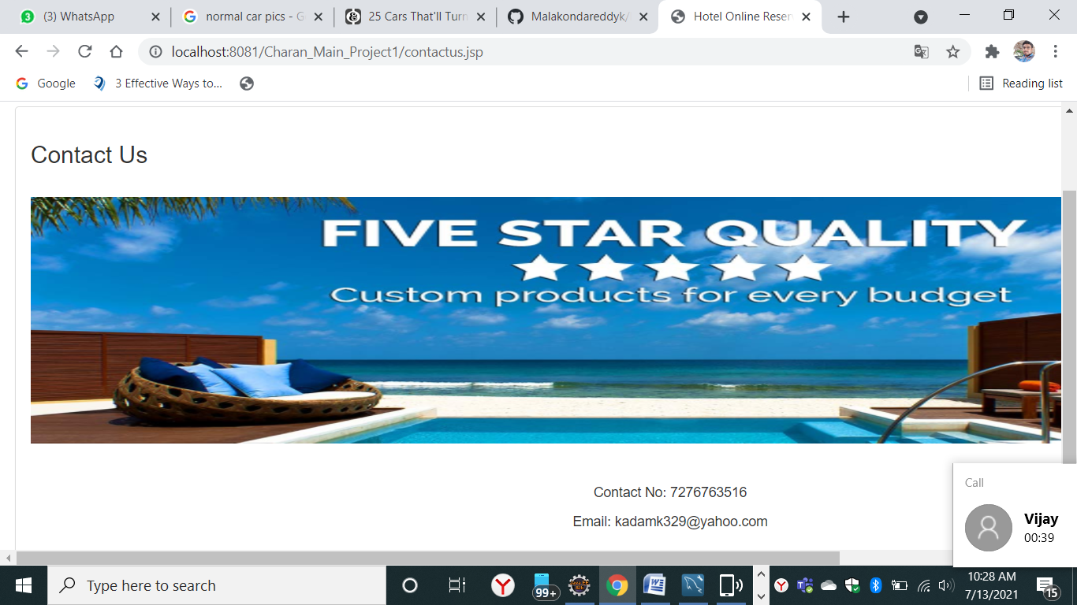

**Gallery Page:**

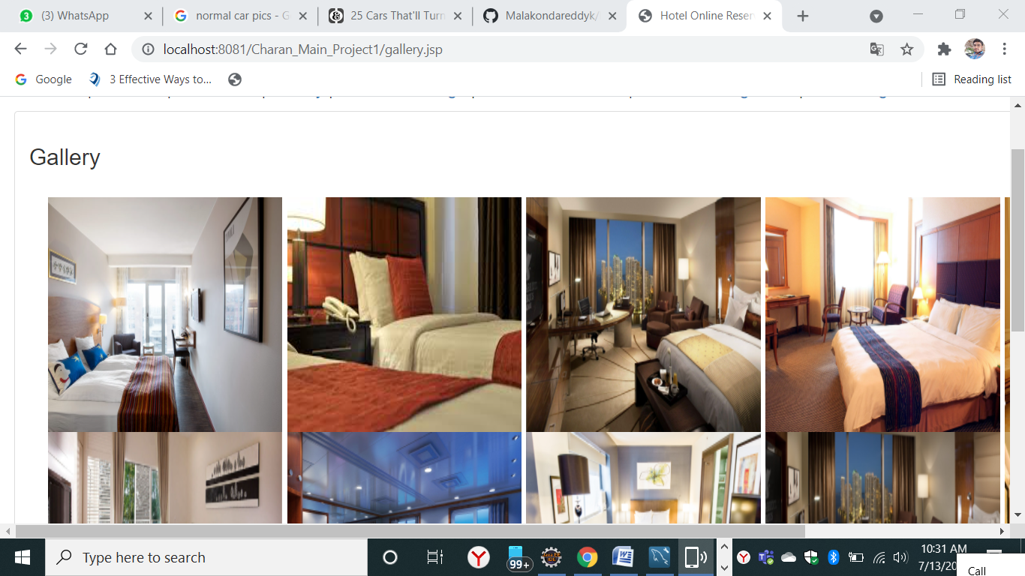

**Dine and Lounge Page:**

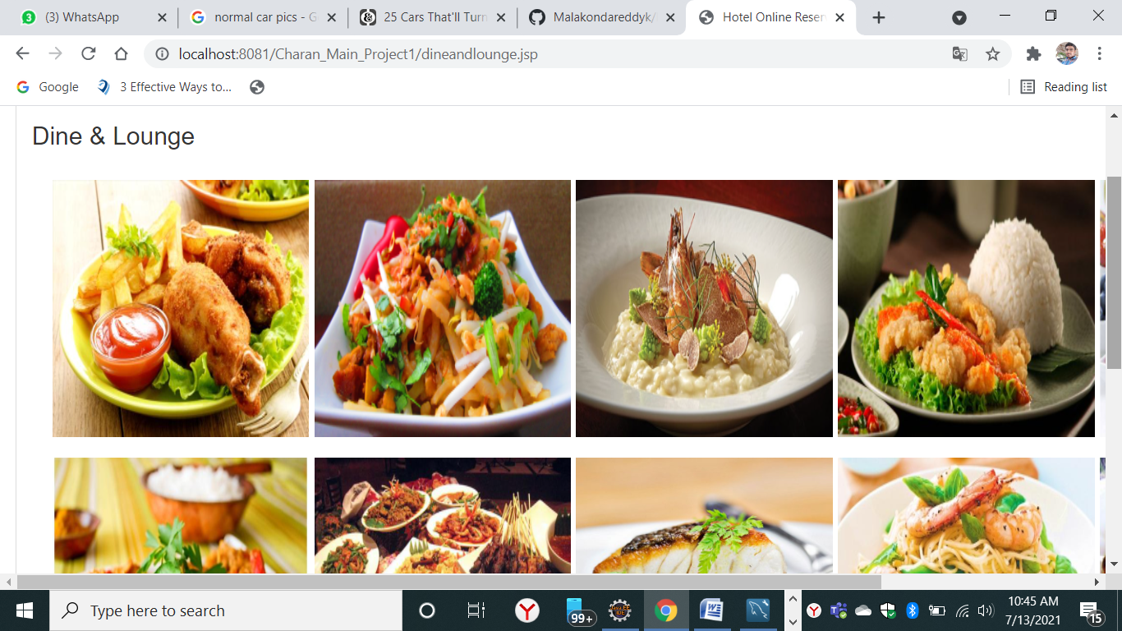

**Make a Reservation Main Page:**

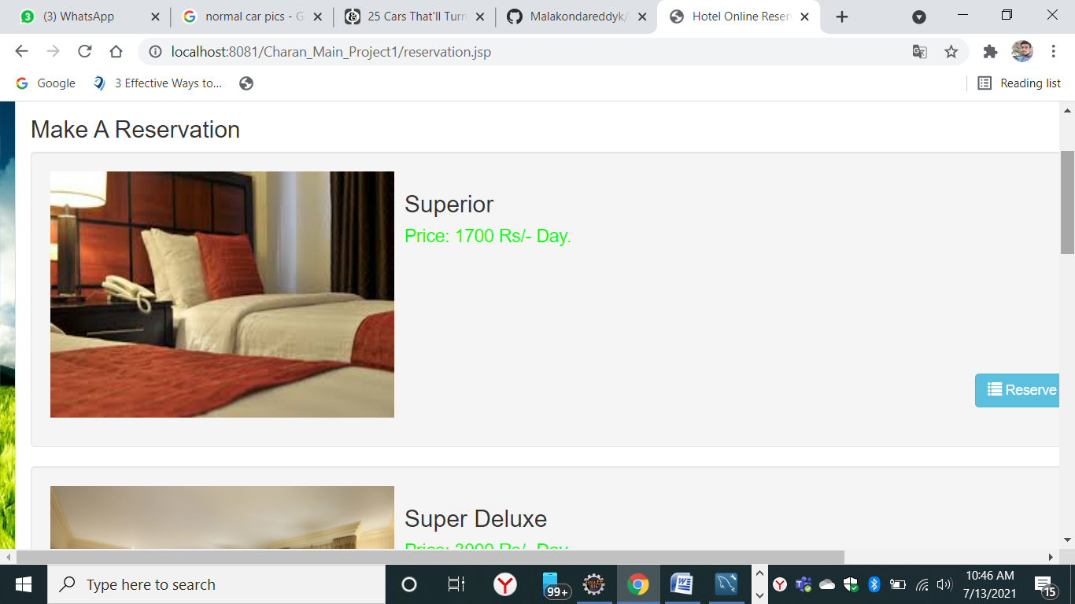

**Room Reservation Page:** 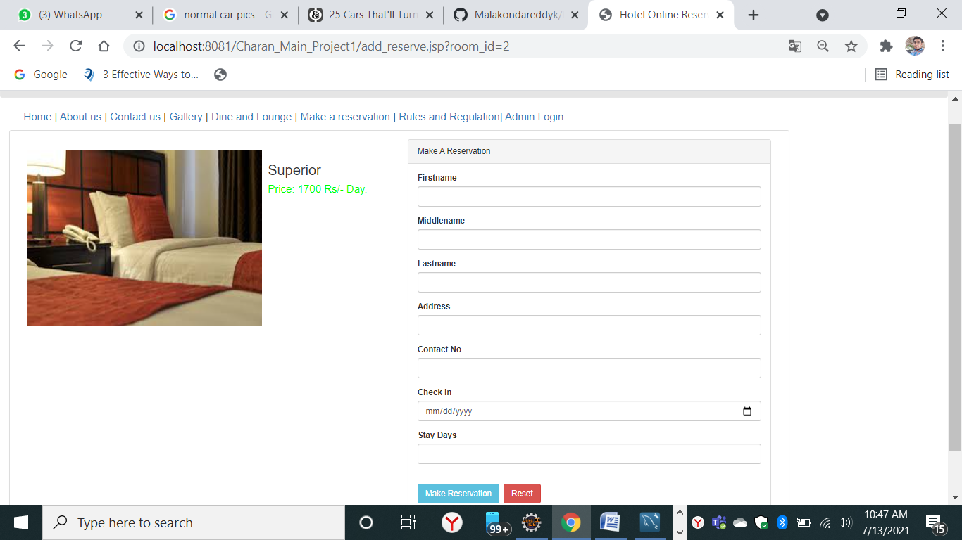

**Data Added in Database SuccessFully:**

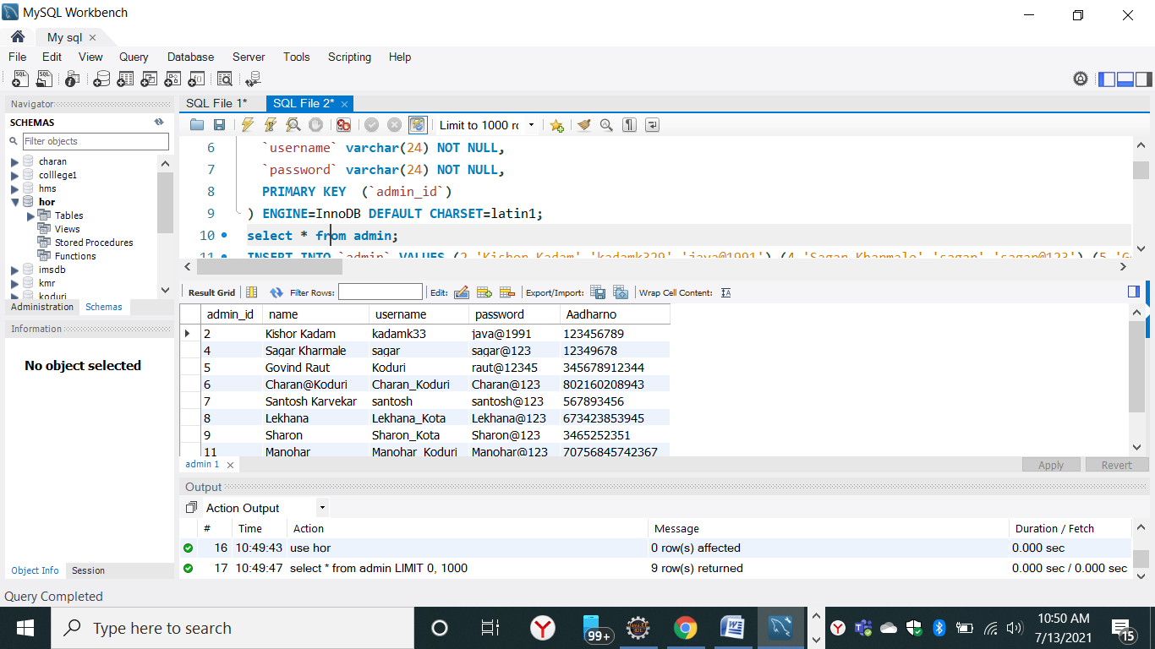

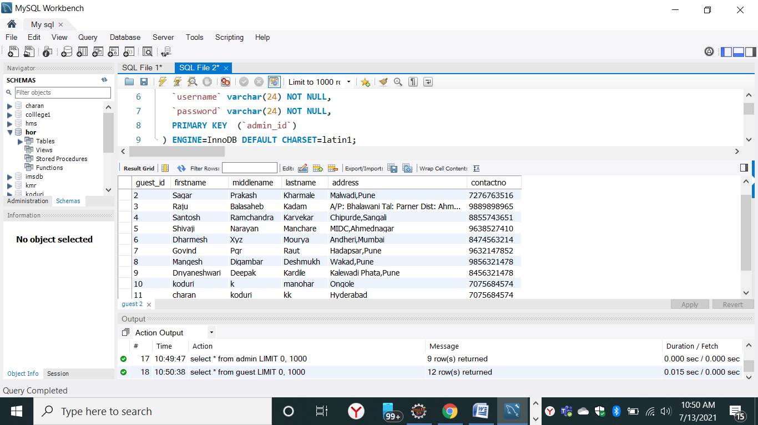

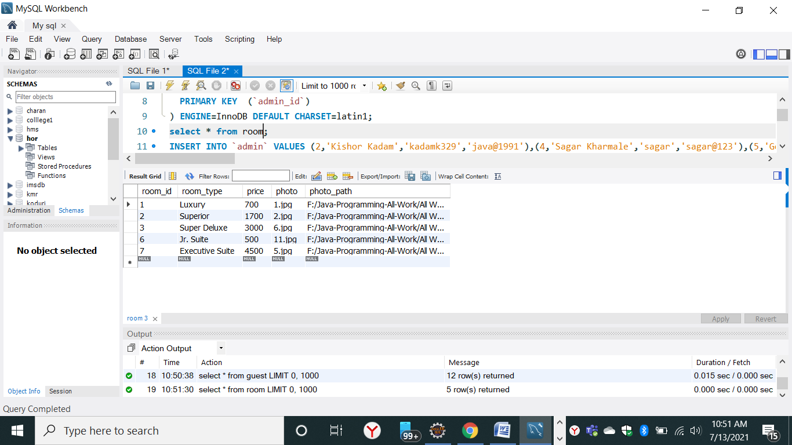

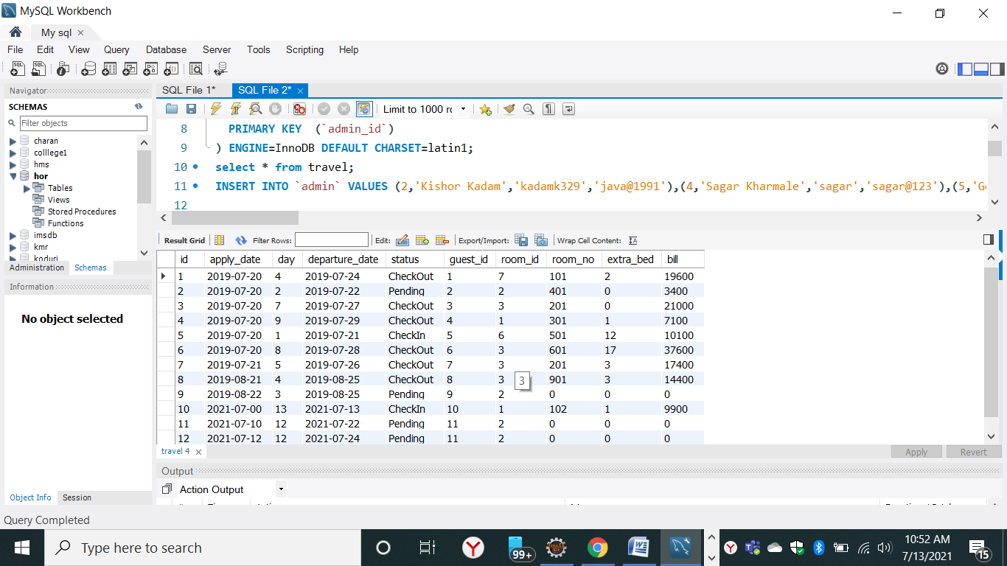

**Thank you**